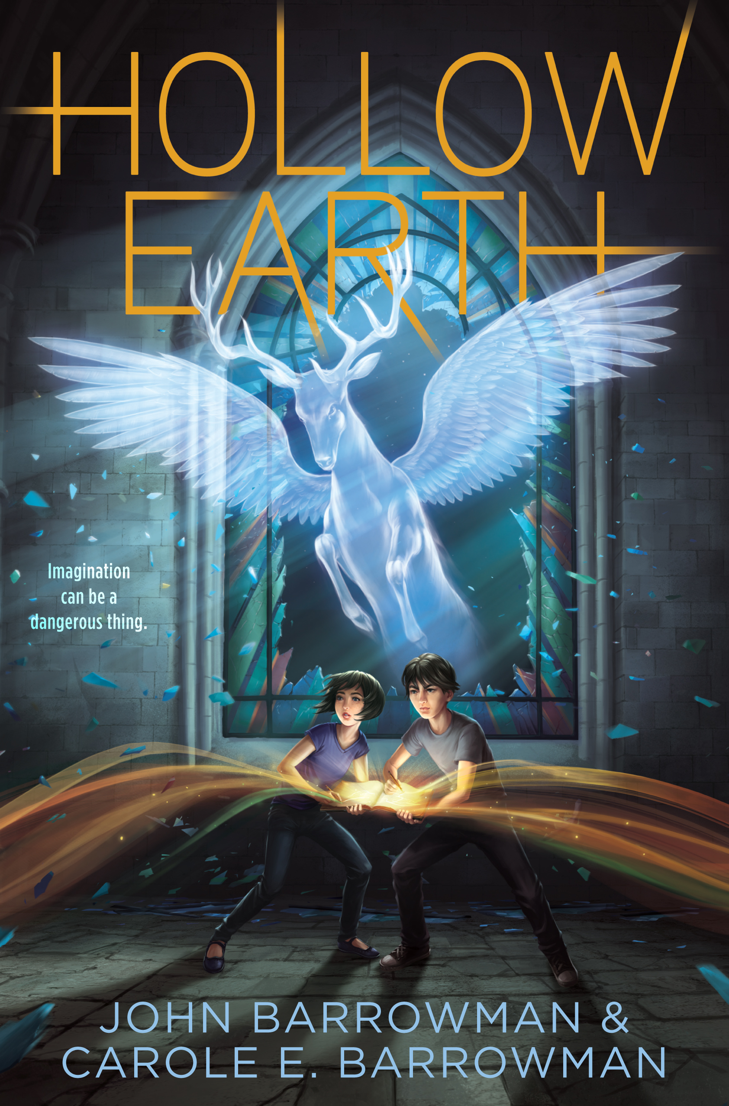Hollow Earth Lesson Plan
Carole Barrowman
Creating a Class Bestiary
Ages 8-14

Can be adapted to meet core outcomes for Language Arts, Art, History

Goals:
To demonstrate imaginative thinking
To collaborate with peers to design and draw a mythical beast
To understand the role of art and stories in the past and today by applying art and story concepts to the design of a class bestiary
To understand the importance of visual literacy in the past and today

Supplies:

Sketch paper (for drafting beasts)
Newsprint (if beasts will be displayed) or paper for binding into a class book
Colored Pencils
Markers or other drawing supplies

Medieval Bestiaries:

A bestiary is an illustrated book of mythical monsters and beasts, usually organized alphabetically. These illustrated volumes were popular in the Middle Ages when people looked to nature and to the behavior of animals to help understand the world around them. Bestiaries were popular teaching tools to reinforce appropriate community values like sharing. Although most people during the Middle Ages could not read or write, they would be able to recognize stories associated with animals in bestiaries and the church at that time displayed images of animals from bestiaries in stained glass windows and the architecture of their buildings.

The beasts in medieval bestiaries were often a blend of imagined and real animals and the stories associated with them were designed to teach a moral or a lesson about how to behave. The caladrius that appears in Hollow Earth also appears in a number of bestiaries from the Middle Ages. It was believed to be a massive white bird that could cure diseases and sees into the future. A Peryton, a winged stag, and the Grendel also appear in the book. The Grendel is inspired by the hideous monster that must be defeated in the long Old English poem Beowulf.

Today we continue to have versions of bestiaries–now we call them alphabet books–the most popular ones still teach us something about the world around us.

Assignment: To create a class bestiary that includes individual beasts designed by children.

The beasts must have three imagined parts (top, middle, bottom), a power of some kind (power to freeze anyone it looks at), and it must be named. Teachers can assign children a letter of the alphabet for the name of their beast or simply work with what the children create on their own. The beasts and their descriptions can be bound and displayed. For older children, they can be assigned to write a story, featuring their beast that can be displayed with the art.

A number of famous illustrated bestiaries are available online, the most famous is The Aberdeen Bestiary.

Procedures:

- Organize children in groups of three. Each child will be responsible for a third of its imaginary beast for the class bestiary. Give each child a sheet of paper to draft the top, the middle or the lower part of its beast. The children should not share or combine their work until they’ve each had time to design their contribution.
- Give groups time for the children to explore how they will fit together each of the parts of their beast. They will need to negotiate with each other how their beast will look and they’ll need to negotiate the nature of their beast’s powers. For example, if the top have of the beast can breathe fire, then it may be a difficult power to utilize if the rest of the beast is a fish.
- Create the final image of the beast. There are a number of ways that this can be facilitated–three separate sheets, combining them afterwards, or folding newsprint into thirds, allowing each child to draw their own creation on a section, or each child takes a turn working on the same drawing, dividing up the task according to his or her own strengths.
- Each group should collaborate on the description of their beast to be included in the class bestiary. The description should include a). naming it b). describing its parts c). describing its powers.
- Depending on the grade level, link this project with a fuller writing assignment and ask each group or each child to write a story with their beast in it. Their writing could be set off with an illustrated opening letter as was the tradition in medieval bestiaries.

